IMPLEMENTING CRM FOR RESULT TRACKING OF A CANDIDATE WITH INTERNAL MARKS (DEV)-(SHORT –TERM)

**Team ID :** LTVIP2023TMID11579

**Team Leader :** N KARTHIK

**Team member :** N PUNEETH KUMAR

**Create Report**

1. Click App Launcher

2. Select Candidate Internal Result Card App

3. Click reports tab

4. Click New Report.

5. Click the report type as Semesters with Course Click Start report.

6. Customize your report, in group rows select - Course Name, in group column Select Duration (In this way we are making a Matrix Report).

7. Click refresh

8. Click save and run

9. Give report name – Candidate Internal Result Report

10.Click Save

NOTE: In this report you can see your all record of the object you selected for reporting (What you Selects in “Select a report type option”).

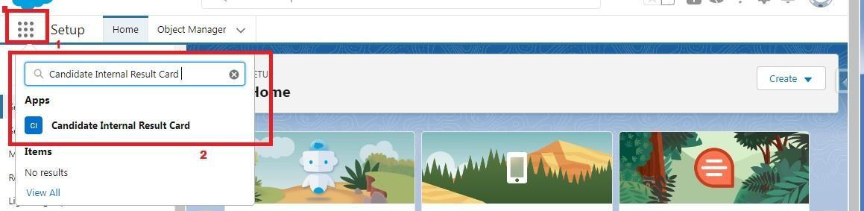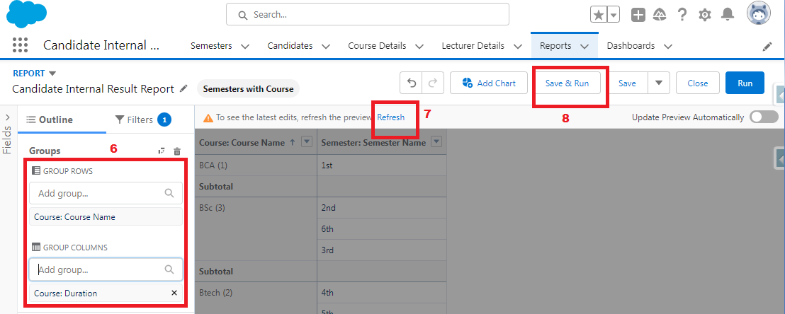

1.    On the report builder page, locate the "Fields" pane on the left-hand side.

2.    Find the field for which you want to create a bucket field and drag it to the report preview section.

3.    Click on the field in the report preview to open the field properties.

4.    In the field properties, locate the "Summarize" option and click the drop-down arrow.

5.    Select "Bucket Field" from the available options.

6.    In the bucket field settings, define the buckets based on your requirements. You can specify the bucket ranges, labels, and groupings.

7.    Click "OK" or "Apply" to save the bucket field settings.

8.    Customize the report layout and add any additional fields or filters as needed.

9.    Once you are satisfied with the report setup, click "Save" to save the report.

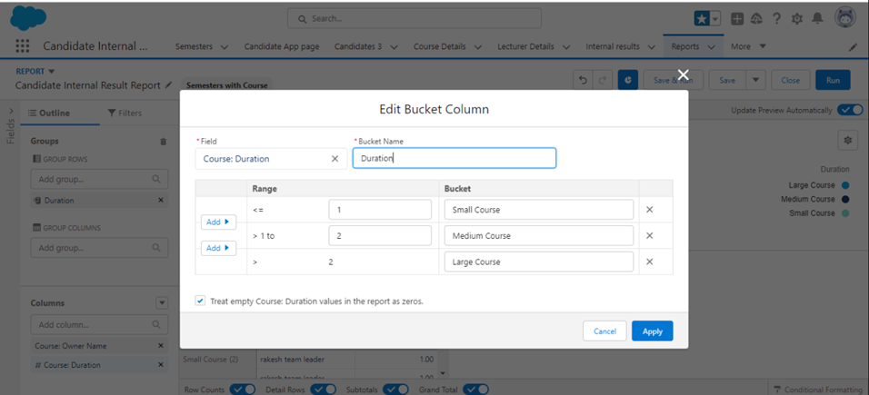

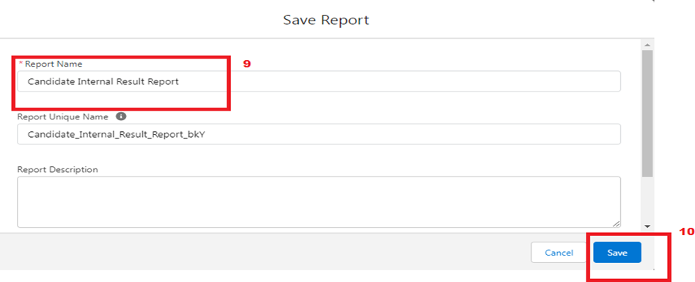

**View Report**

1. Click on App Launcher on left side of screen.

2. Search Candidate Internal Result Card App & click on it.

3. Click on Reports Tab.

4. Click on Candidate Internal Result Report and see records.



### fgshgrwfsdfvc.pngCreate Dashboard

1. Click on Dashboards tab from the Candidate Internal Result Card application.

2. Click on new dashboard.

3. Give name- Candidate Internal Result Card

4. Click create

5.  Give your dashboard a name and click on +component

6. Select the Candidate Internal Result Report which you created.

7. For the data visualization select any of the chart, table etc. as per your choice/requirement.

8. Click add.

9. Click save.­­­­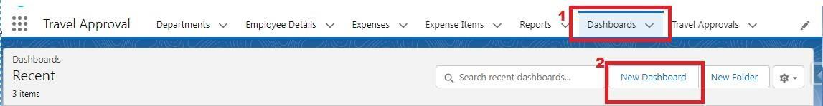

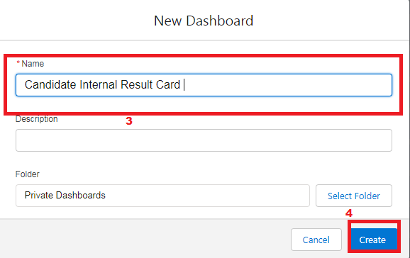

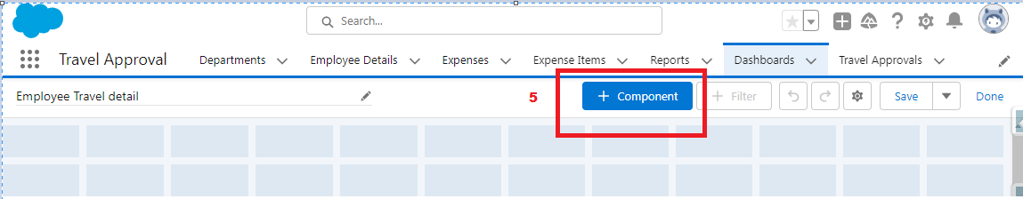

### dfsab fdvbfda.pngView Dashboard

1. Click on App Launcher on left side of screen.

2. Search Candidate Internal Result Card & click on it.

3. Click on Dashboard Tab.

4. Click on Candidate Internal Result Card see graph view of records



